XSD - Description Mapping document

1. Run all the DDL INCs (column level comments) in the required Db which we will get these INCs from PS.
2. We can see all the comments in the default table i.e. user_col_comments.

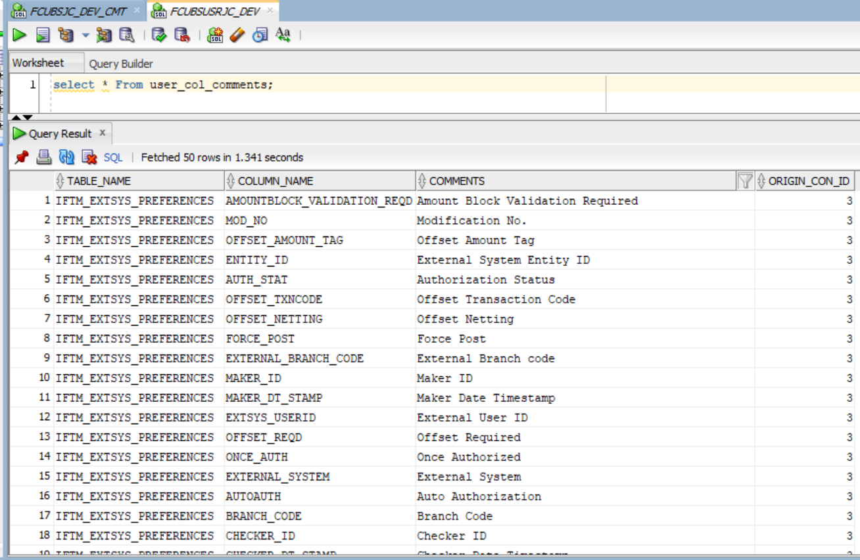

1. Run the attached java file and get the field level details like Block_name,Blk_Field_Order,Field_name,Field_size,Data_type,annotation,Max_length,Default_Value,Display_Type,DBC,DBT from RAD XML. To get these details, provide the required RAD xmls(path) as input and store these values in the customized table like below.



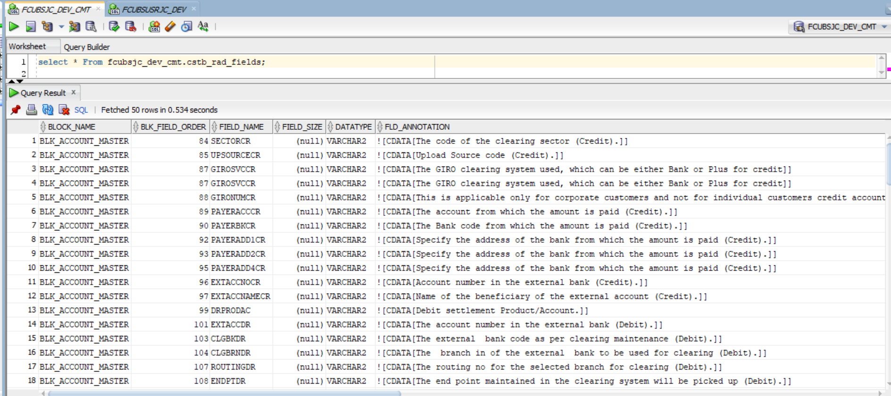

1. From the above table, identify any field does not have the fld_Annotation value. For those columns get the comments from the **“user_col_comments”** table and update it here based on table name and field_name/column_name
2. Get all the Required xmls from vercon path into local system. Pls refer the screen shot

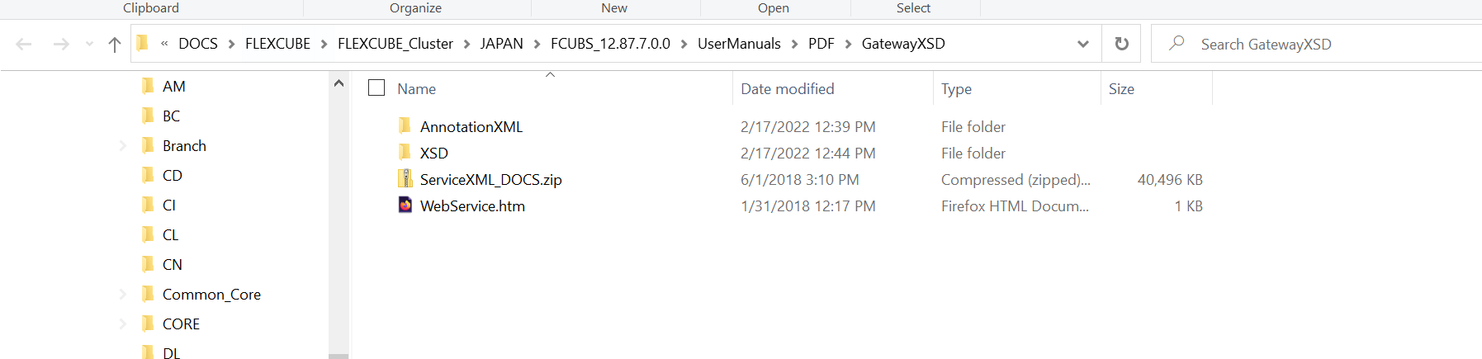

1. Run the attached python script to update the xmls comments in the xml files by giving all the xml file names(without any extension) in text file(Data_import.txt).

Python script will read the text file and take one by one file name from text file, then process that xml by updating the <Comment> </Comments> tag in the xml for this, it will take the data from customized table (cstb_rad_fields)



1. Once process/update all the comments/descriptions in the xmls, to test these xmls prepare the sample web ear file and deploy it in Web logic and launch the application. Please refer the attached war file for reference.



1. After successful deployment, we can be able to see the application like below.

